C PROGRAMMING TO CHECK GIVEN NUMBER IS ARMSTRONG OR NOT

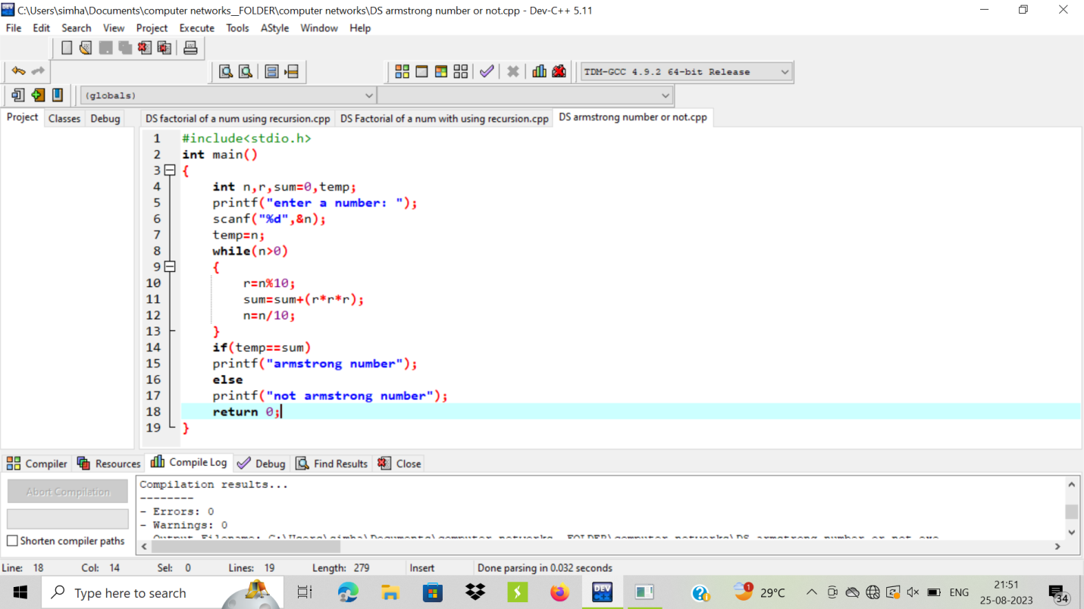

OUTPUT:

